# DPV ASSIGNMENT 4

S1752065 – Mike Pingel – Ernst de Vries

1. A good beta tester for a particular company is determined foremost by the match of player profile with the game the developer is creating. Important in this case is that the player has experience in playing the same genre as the game to be tested. Furthermore, the player needs to show a good record of high play scores in this particular genre. The genre data can be found under category in the warehouse and the scores can also be found there. Another important factor is that the player is reliable and that he/she has a consistent record of completing beta tests instead of stopping halfway through. This can be seen by the saved game stages that the player went through in other games. If the player completed a lot of other beta apps, he/she would get a higher score of course. Finally, the player needs to be active so that no inactive players will be chosen that will never start the game. This can be seen in the timestamps for starting apps that are saved about the player. A player will only be chosen if the last timestamp was recorded in recent time. The requirements are summarized below:
2. Player is experienced and reliable in the genre of the game.

Measurement: [Number of completed games played in genre] - Integer

1. Player has good scores in genre of game.

Measurement: [Average score of completed games in genre above 60%?] - Boolean

1. Player is active.

Measurement: [Active within the last 2 months?] – Boolean

To quantify all this information the following formula is being proposed:

[Average score of completed games in genre above 60%?] x [Active within the last 2 months?] x [Number of completed games played in genre]

1. What are the top potential beta testers for a development company in the Pear store?

How much time do beta testers spend on playing the beta?

How much does a company have to pay for their beta testers?

1. 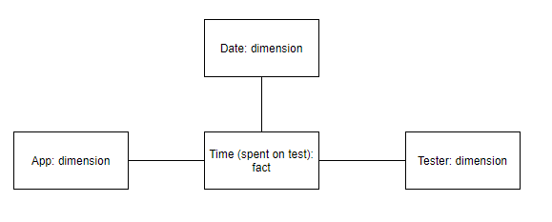

As can be seen in the graph, the fact that was chosen is the time spent on testing a game. This is considered as being the most important variable to measure, as it coincides with the goal of the developers to know about how much their beta tester are using their app. Additionally, the assumption was made that the cost for the developers could be inferred by the time the tester are using the app. It is assumed that a player can earn more money the longer the test is, which is a reasonable assumption to make. Furthermore, it is also assumed that potential testers with 0 test time fall under the category of testers, too. The requirement for this is that they made an account on the Pearl App Store and requested permission for beta test use. They are also required to have downloaded and used an app before on the store, even if this app usage was no beta test. Otherwise, the score for this user would be 0 according to the formula made in b. The score for the potential beta test user can be inferred by looking at all the dimensions.